Practical - 1
Practical Title: Project Initiation, Requirement Analysis, Sitemap, Wireframe, and GitHub Setup

Problem Definition: Initiate the semester-long StudentHub portal by identifying the problem scope, user roles, key modules, navigation flow, and minimum 10 pages. Create a sitemap, low-fidelity wireframe, project folder structure, README file, and GitHub repository.

Theory

What is URL and parts of URL?
Answer: A URL (Uniform Resource Locator) is the address of a webpage or website on the Internet that helps the browser find and open the required page. A URL has different parts: the protocol which tells how to connect, the domain name which is the website's name, the path which shows the specific page, and optional parts like the query string for sending extra information and the fragment for opening a specific section of the webpage.

How does HTML file process in web browser?
Answer: When an HTML file is opened in a web browser, the browser reads the HTML code from top to bottom and converts it into a webpage. It creates the page structure using HTML, applies the design with CSS, and adds interactivity using JavaScript. Finally, the browser displays the complete webpage on the screen for the user.

3. How will page navigation flow managed among all HTML pages?
Answer: Page navigation flow is managed by using HTML hyperlinks. Each page contains links to other pages, such as Home, Profile, Attendance, Courses, Results, and Assignments. When a user clicks a link, the browser opens the corresponding HTML page, making it easy to move between different sections of the website.

4. How will GitHub commits be maintained after each practical?
Answer: GitHub commits will be maintained by committing and pushing the project after completing each practical. Every commit will have a clear and meaningful message describing the changes made, so that the project's progress can be tracked easily and previous versions can be restored if needed.

Evidence of Work (Screenshots)
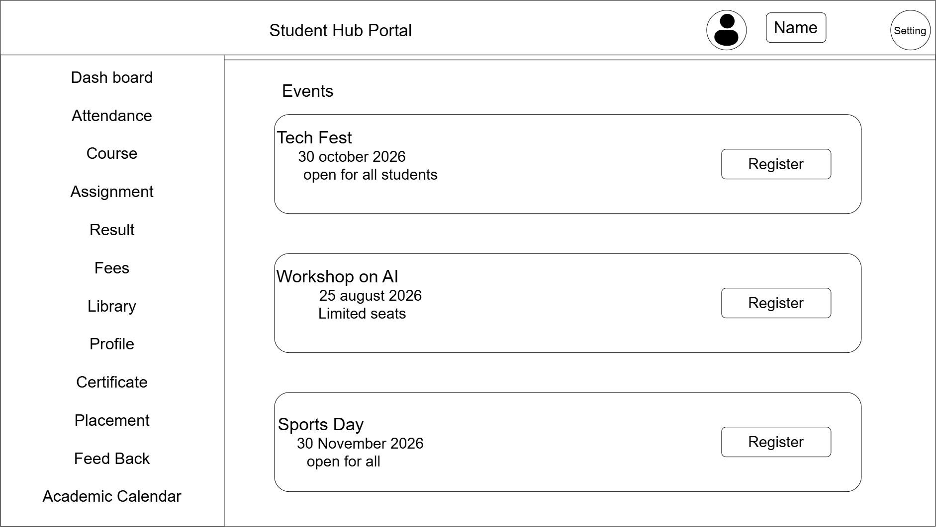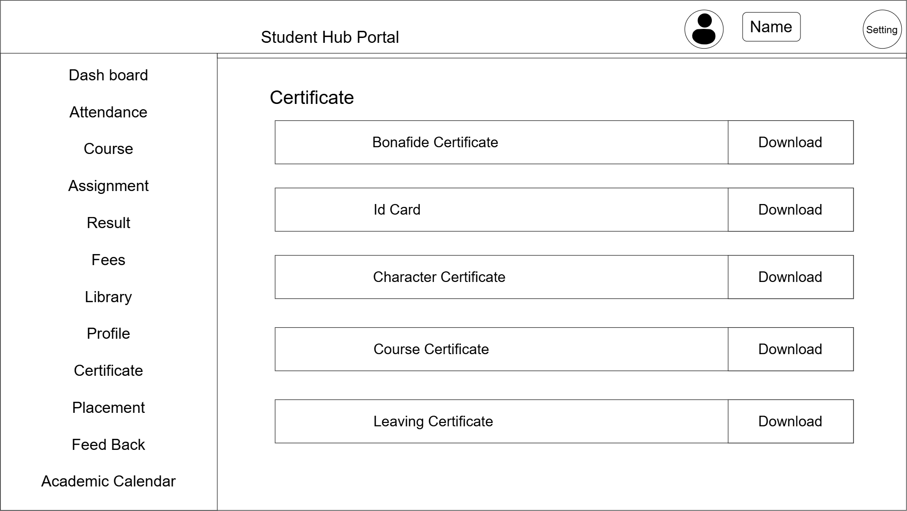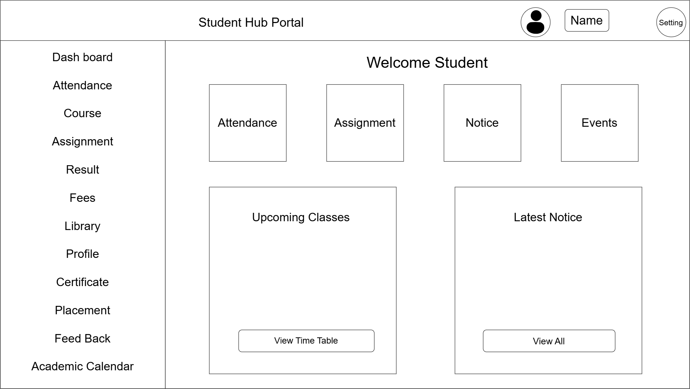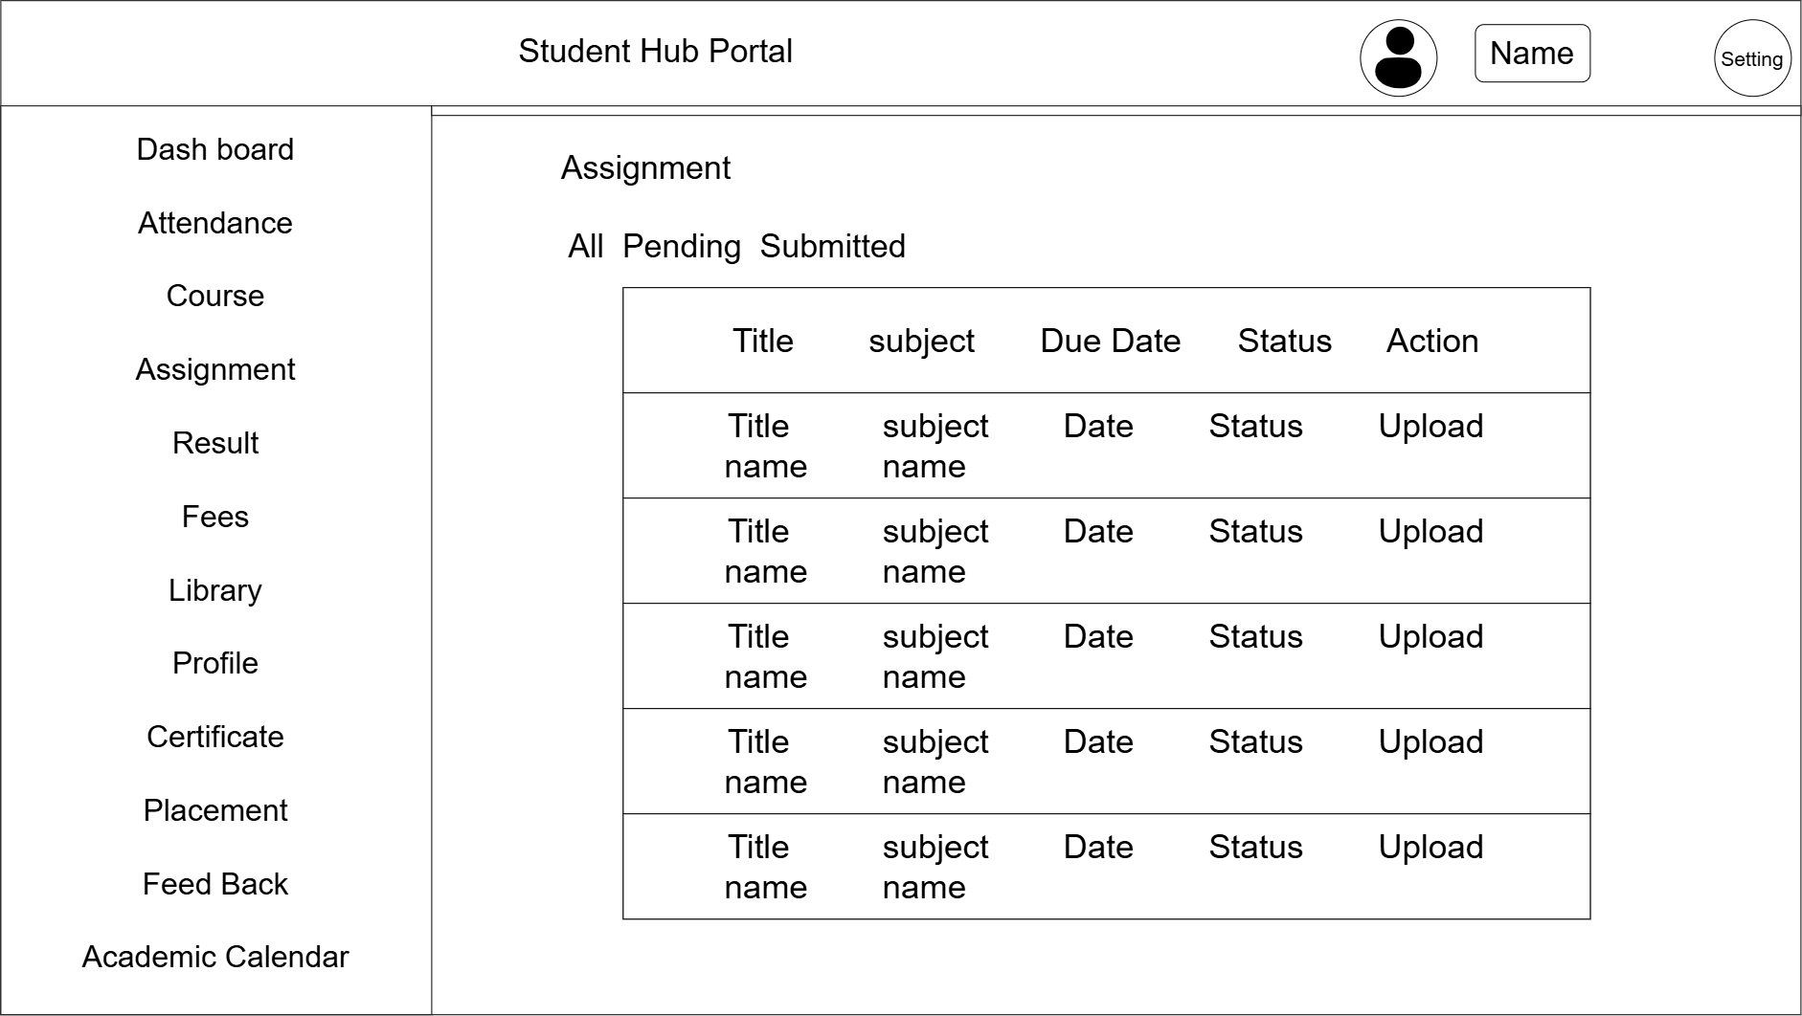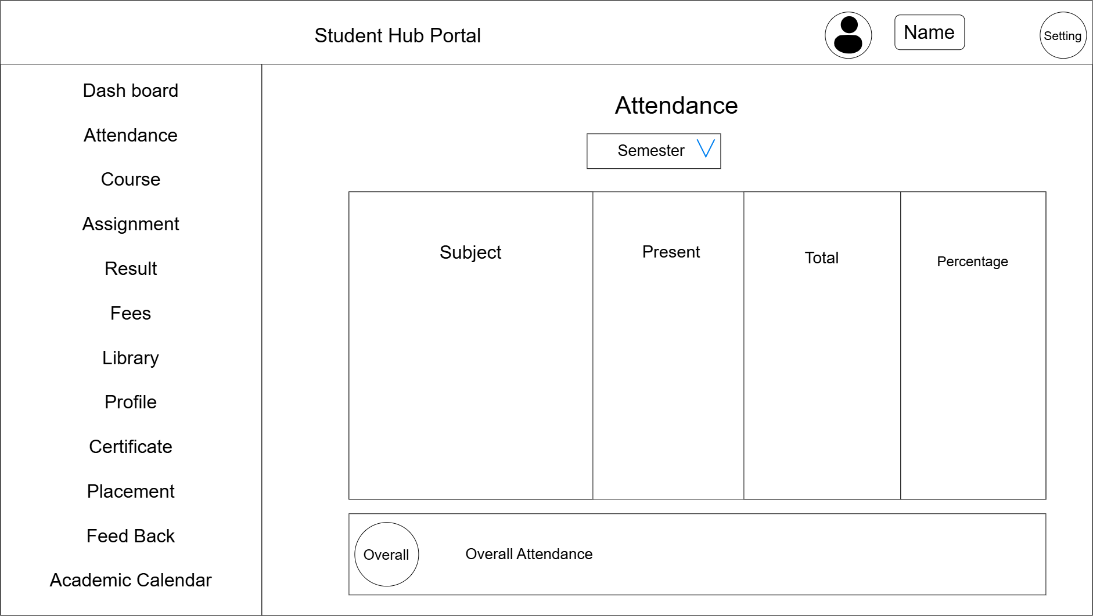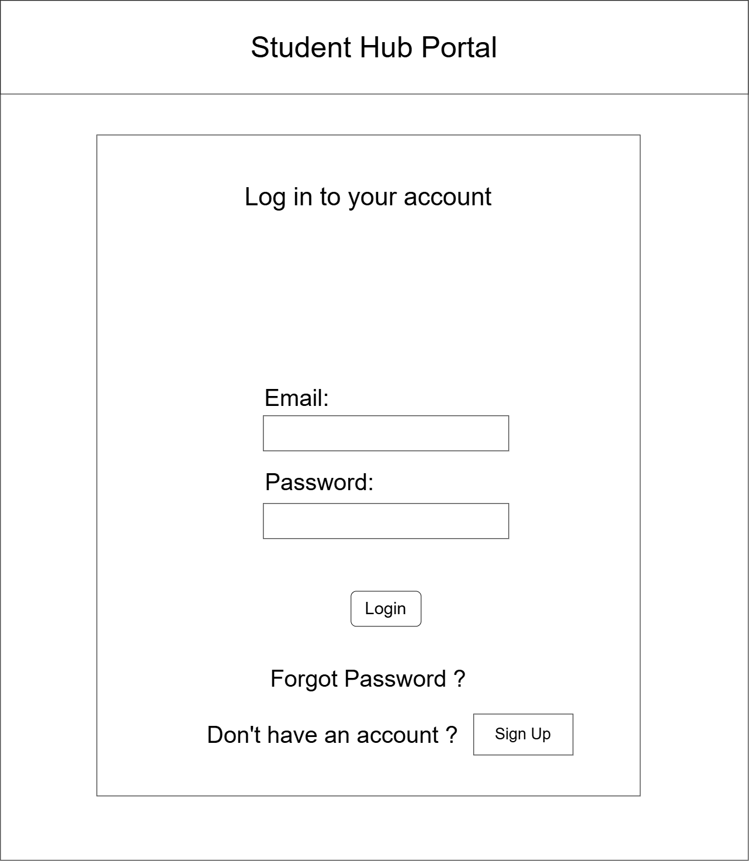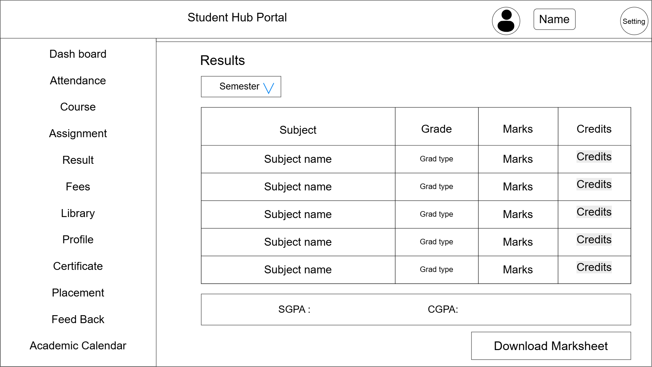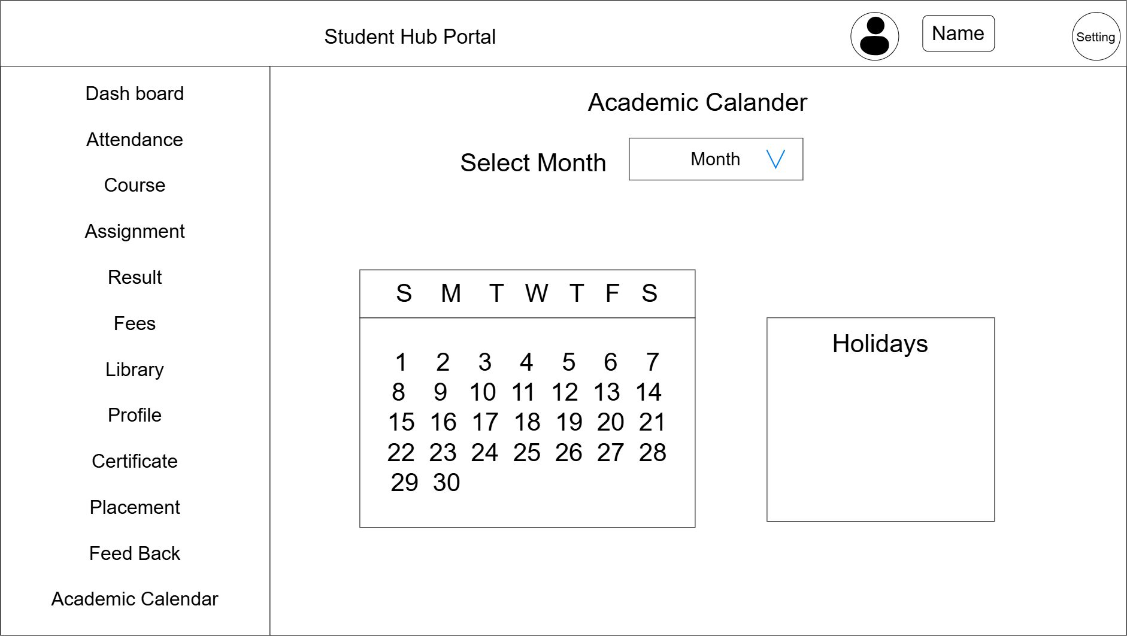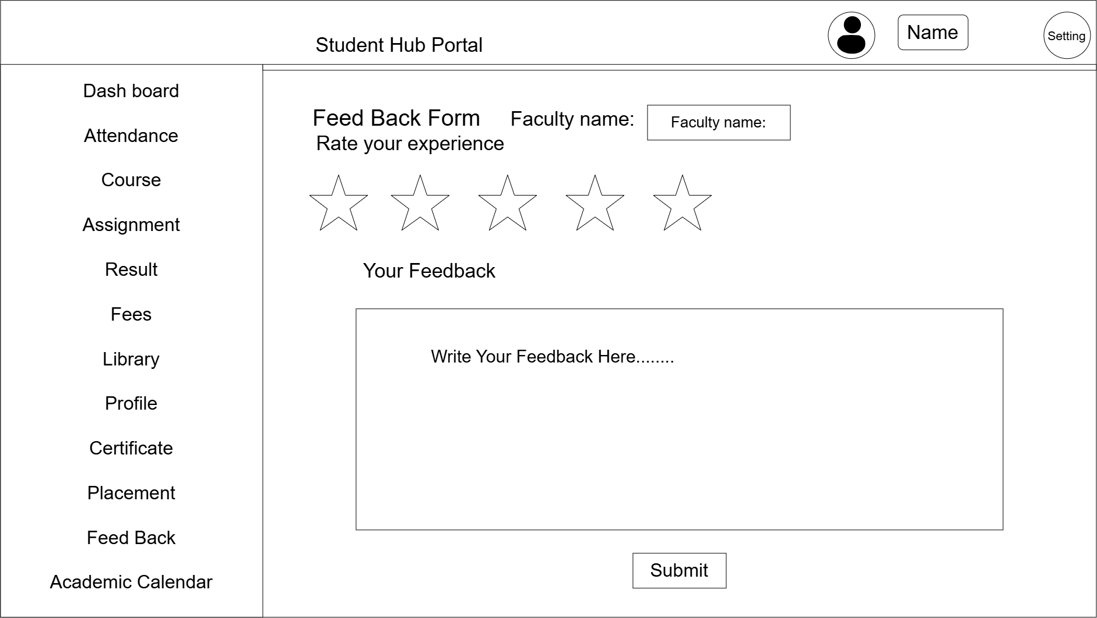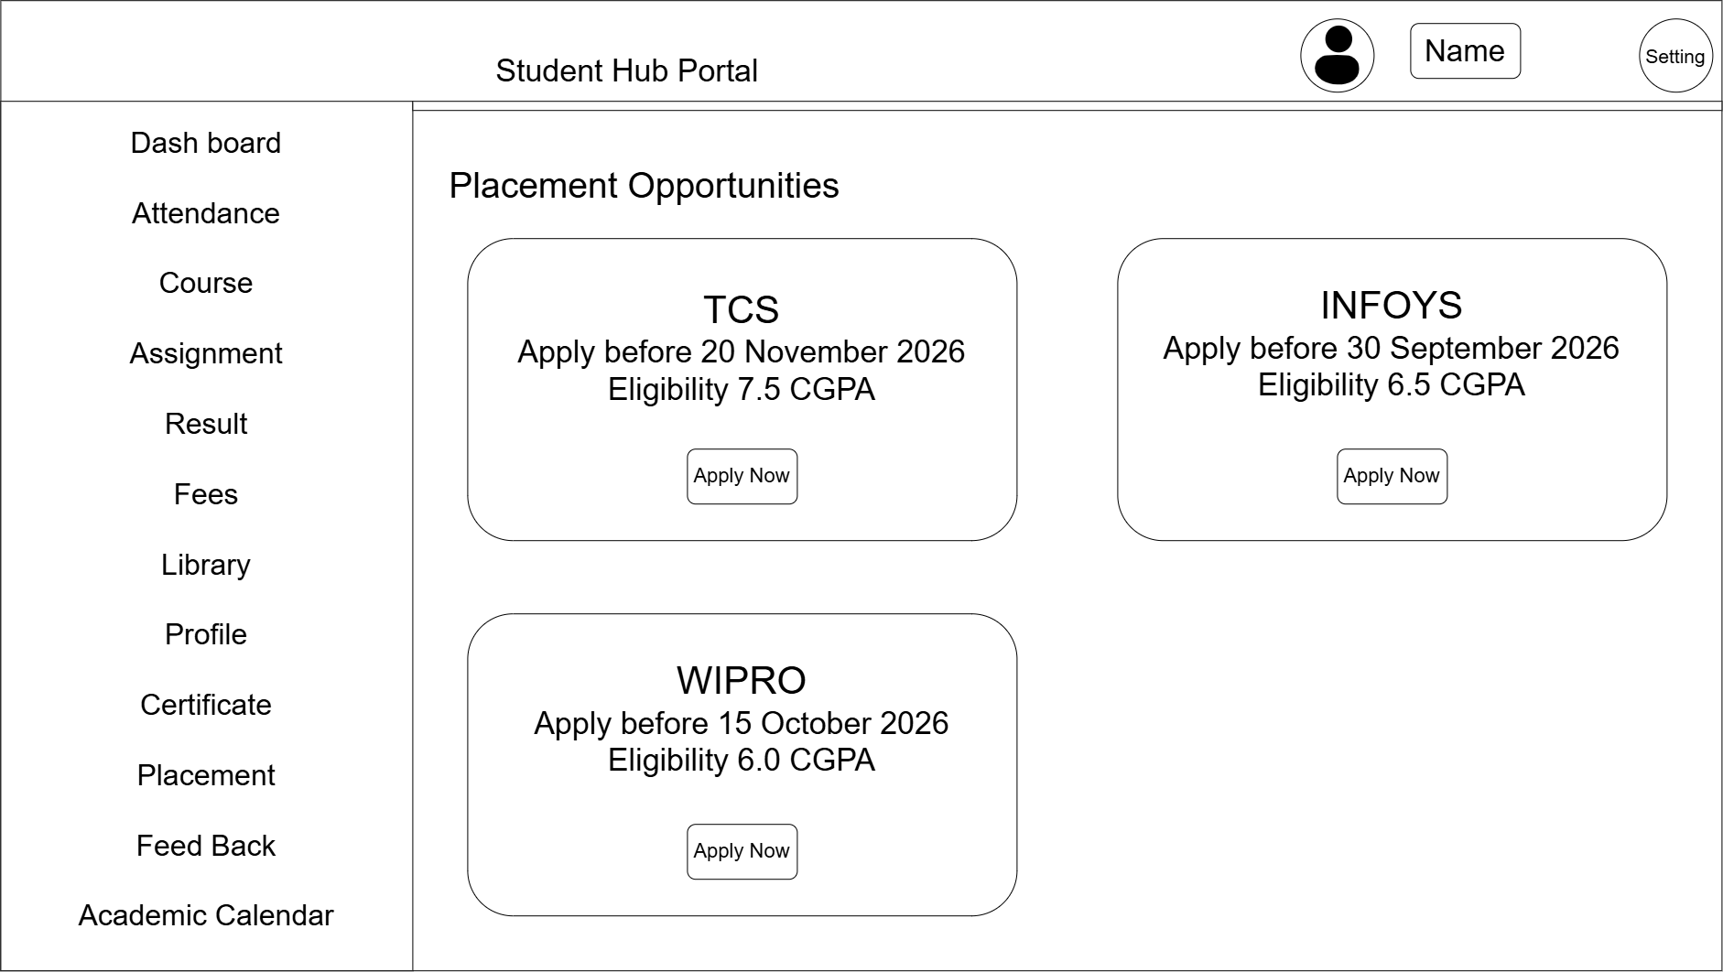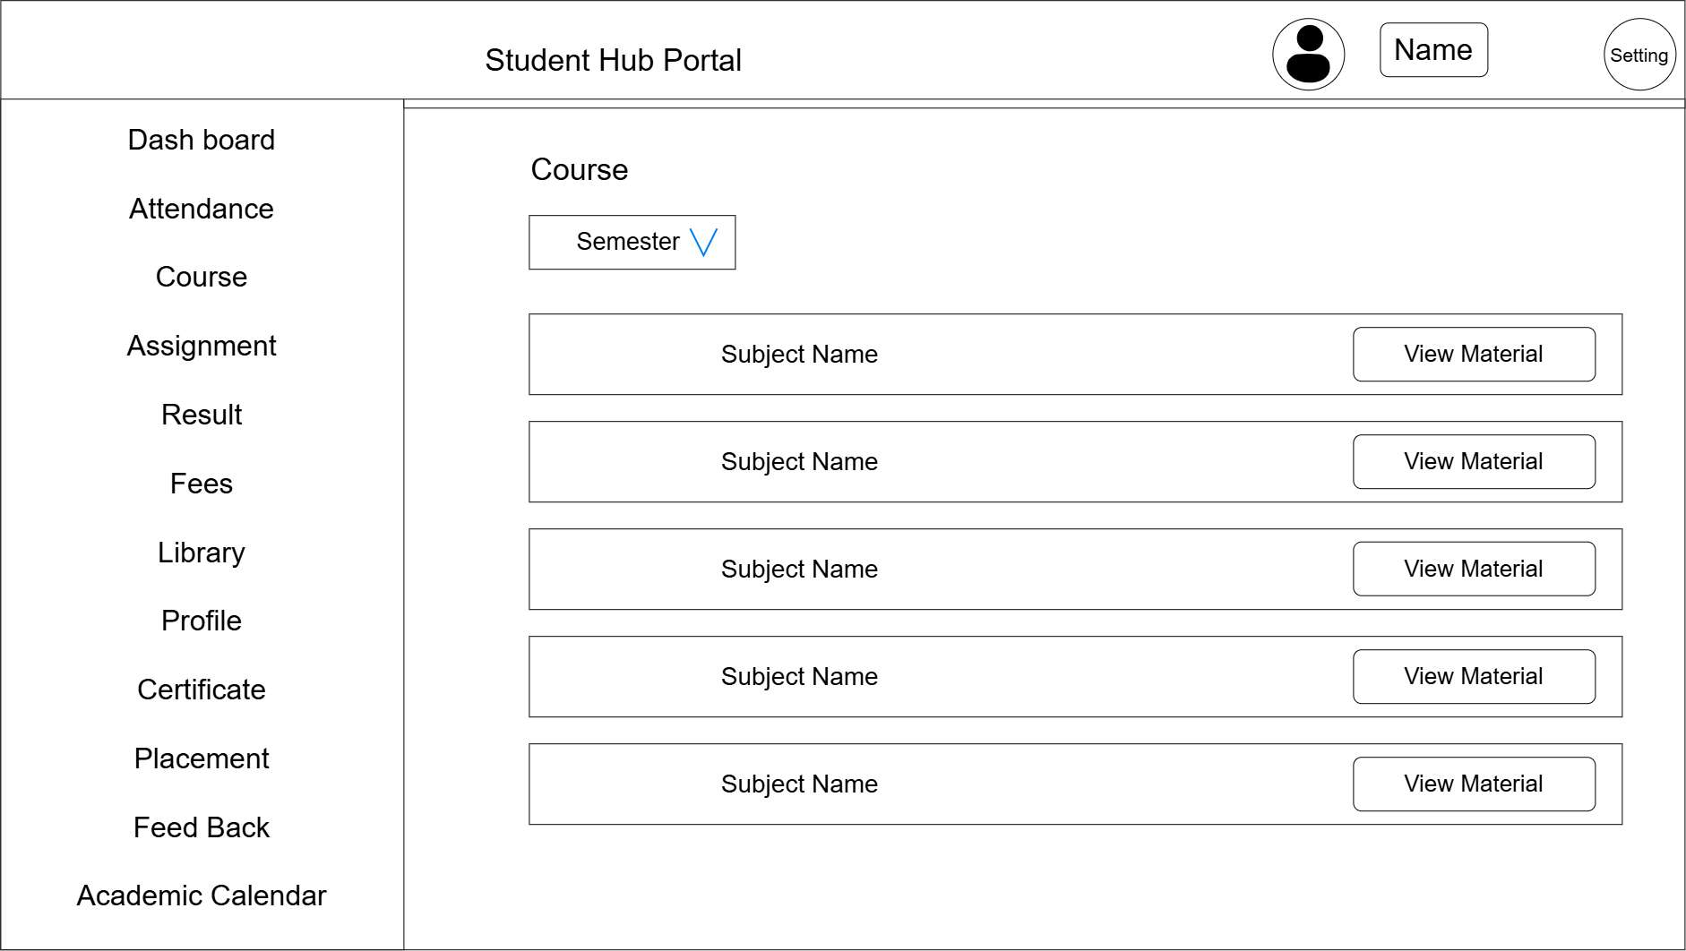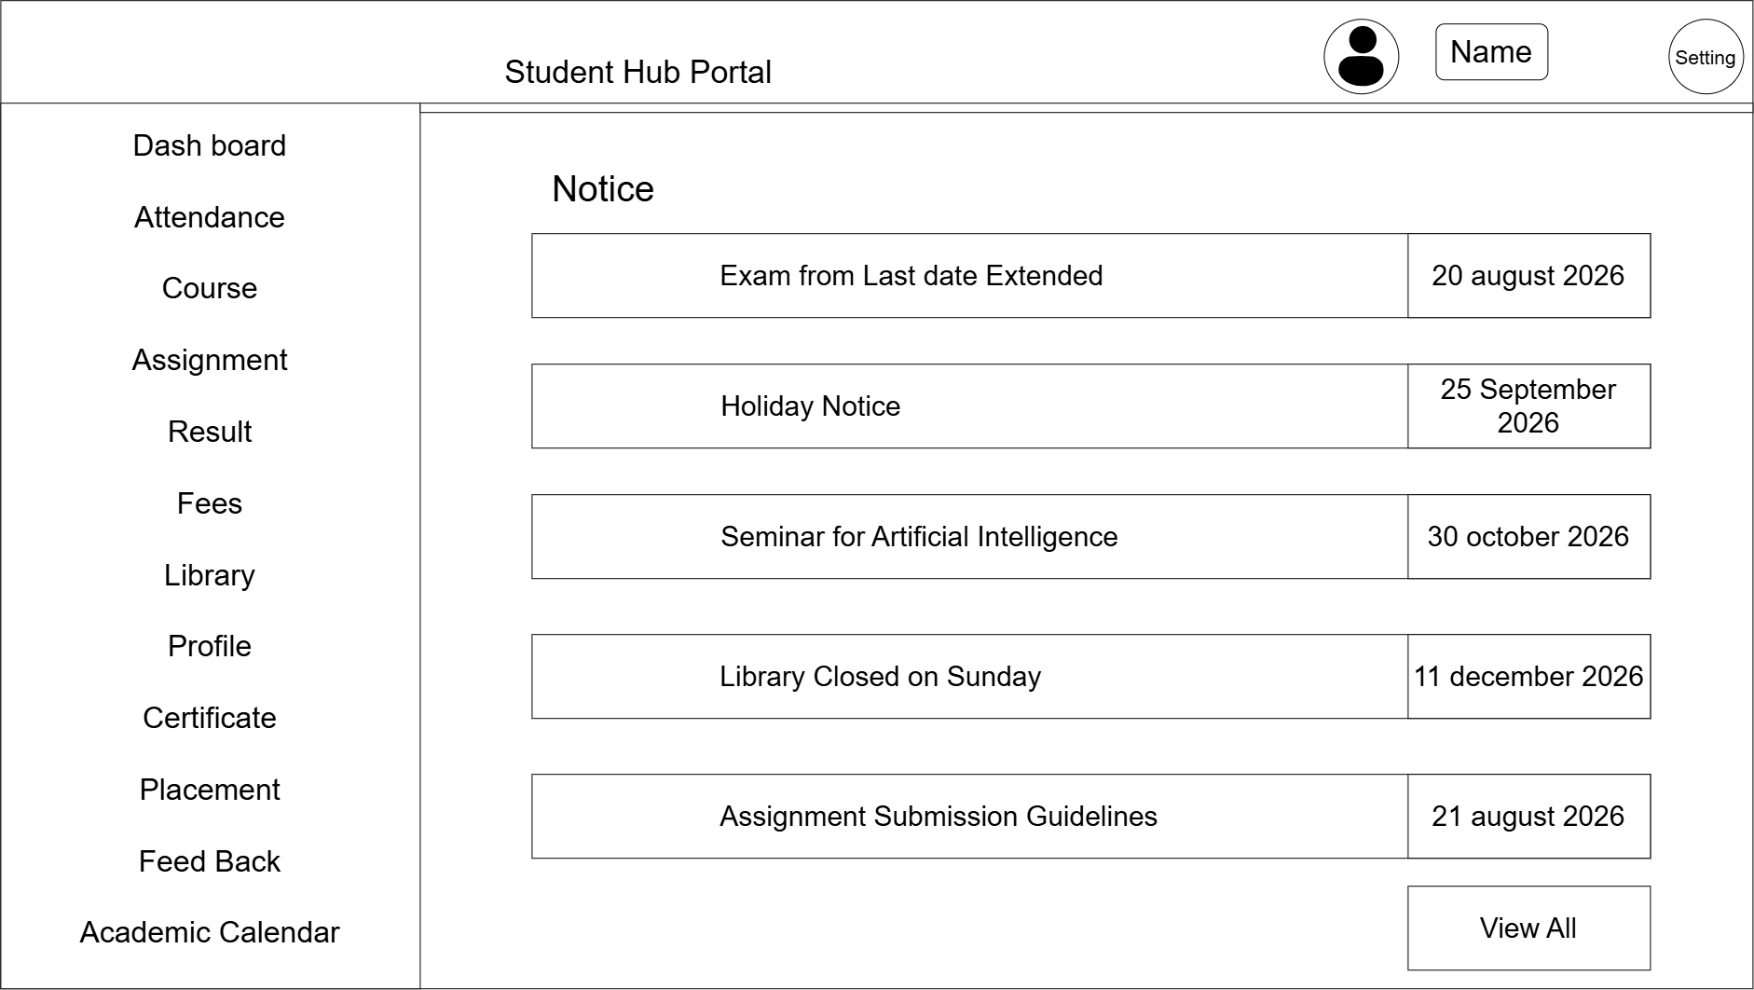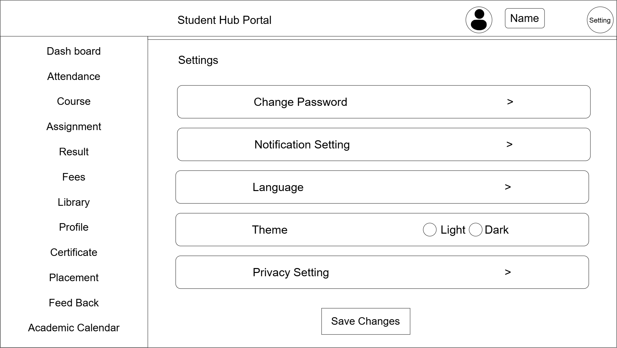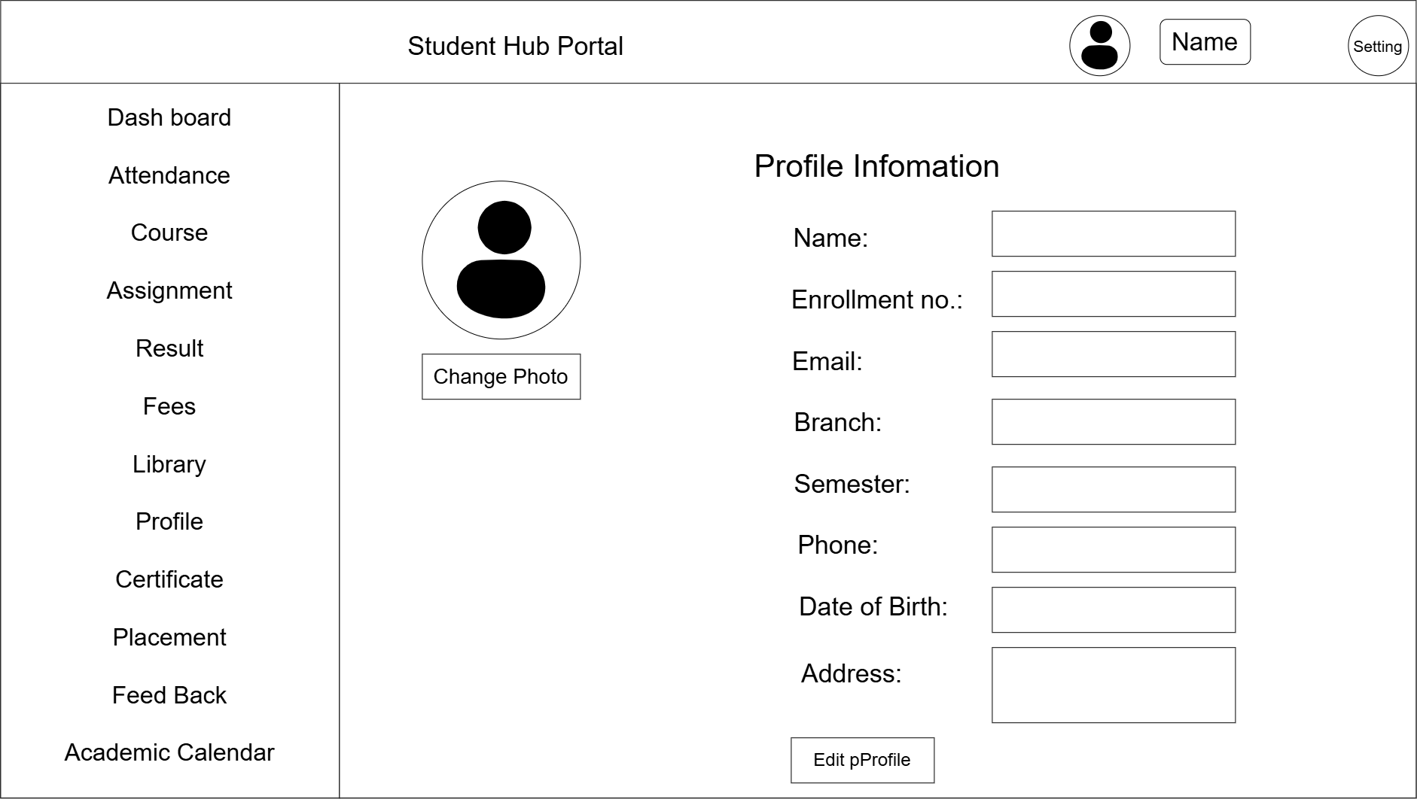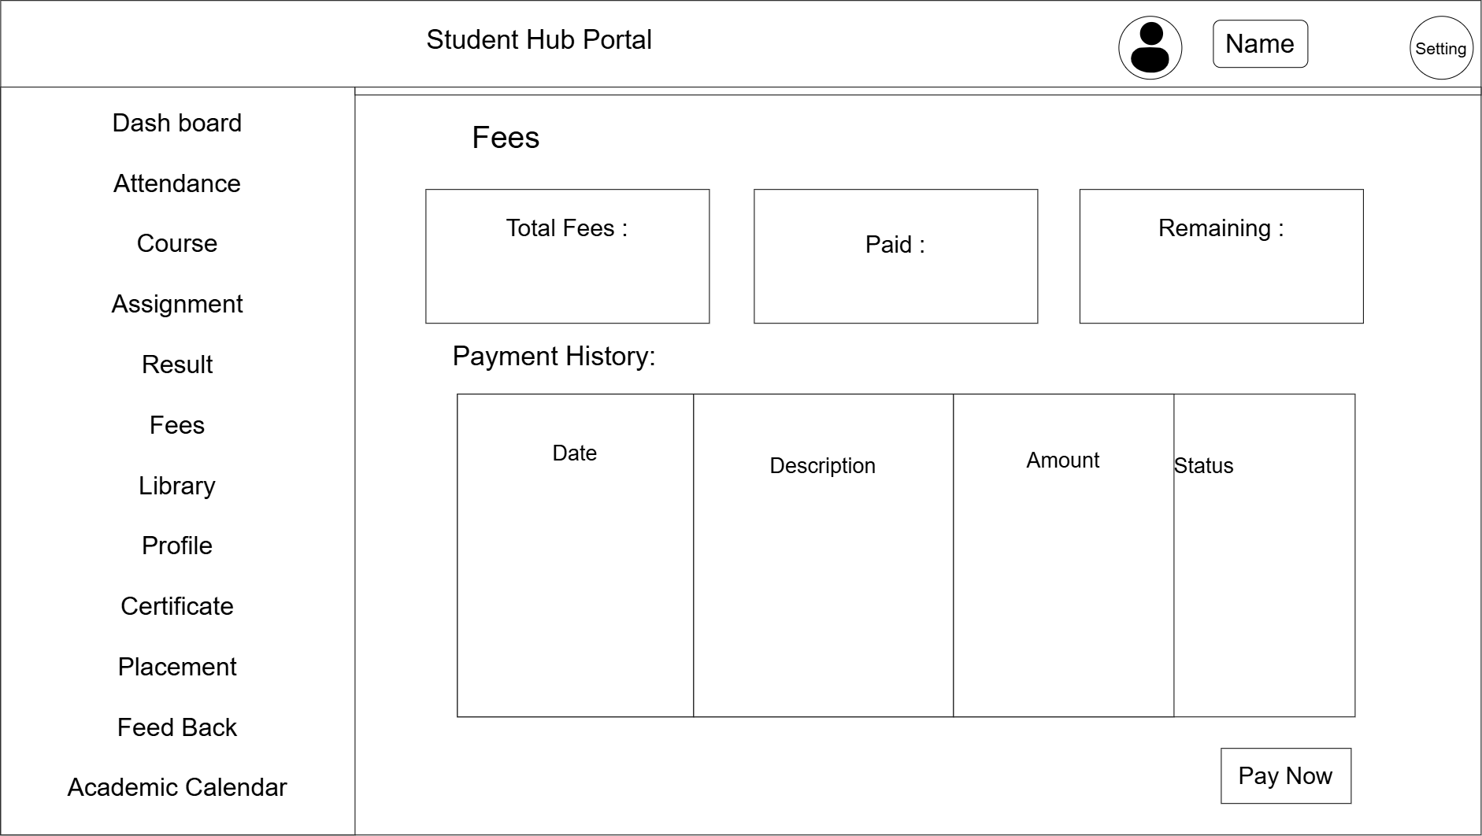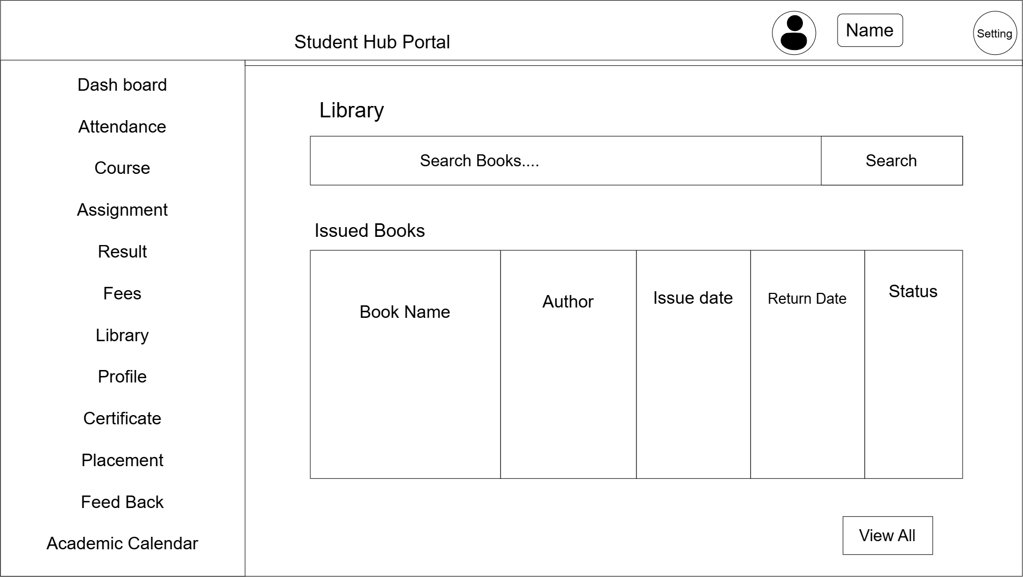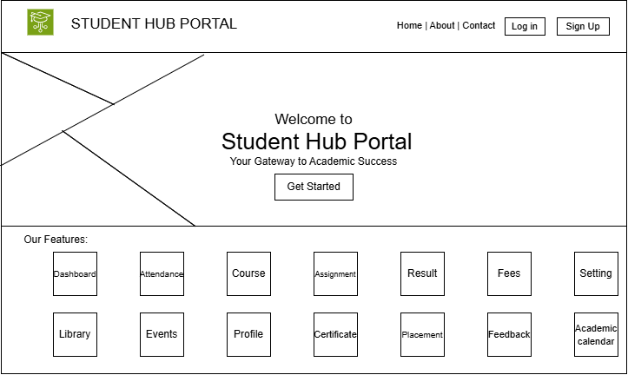

GitHub Repository Link:

https://github.com/Andarpadhruvi1125/Student-Hub-portal.git

Challenges Faced:
While doing this practical, I faced some difficulties in planning the project structure, deciding the pages required for the Student Hub portal, and creating the sitemap and wireframe. I also had to understand how to link all HTML pages properly and organize the project files. Initially, using GitHub for creating a repository, committing changes, and pushing the project was a little confusing, but after practice I understood the process.

Learning Outcomes:
From this practical, I learned how to plan a web project before development. I understood how to create a sitemap and wireframe, organize project files, manage page navigation, and use GitHub to store and track project changes. This practical also improved my basic understanding of project planning and web development.

Faculty Remarks: (Keep this blank for faculty)

